Pic. | Name | Pack.Qty. | Rate in USD
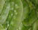 | Avarai
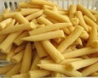 | Baby corn
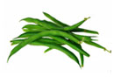 | Beans
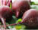 | Beetroot
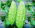 | Bittergourd
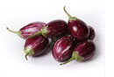 | Brinjal
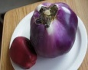 | Brinjal - Big
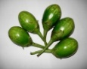 | Brinjal - Green
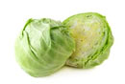 | Cabbage
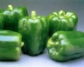 | Capscicum - Green
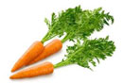 | Carrot
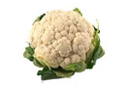 | Cauliflower
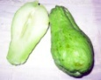 | Chow Chow
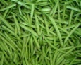 | Cluster Beans
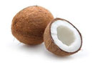 | Coconut
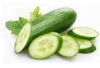 | Cucumber
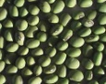 | Double Beans
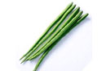 | Drumstick
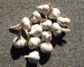 | Garlic - Big
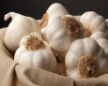 | Garlic - Small
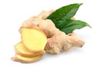 | Ginger
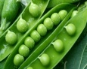 | Green Peas
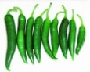 | Green Chilli
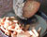 | Karunai Kizhangu
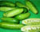 | Kovakkai
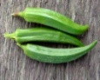 | Ladies Fingers
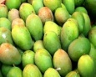 | Mango - Raw
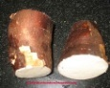 | Maravalli Kizhangu
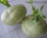 | Noolkol
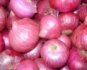 | Onion - Big
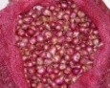 | Onion - Small
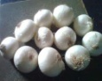 | Onion - White
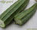 | Peerkankkai
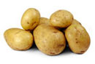 | Potato
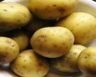 | Potatoes - Baby
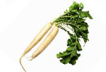 | Radish
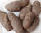 | Senaikizhangu
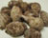 | Seppankizhangu
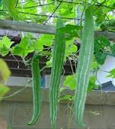 | Snake Gourd
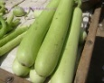 | White Gourd
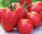 | Tomato - Bangalore
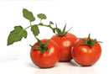 | Tomato - Local
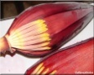 | Vazhai Poo
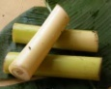 | Vazhai Thandu
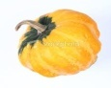 | Yellow Pumpkim

Pic. | Name | Pack.Qty. | Rate in USD
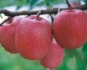 | Apple - Fuji
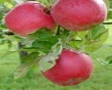 | Apple - Shimla
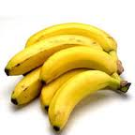 | Banana - Elachi
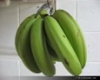 | Banana - Hills
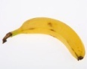 | Banana - Karpoora / Honey
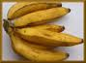 | Banana - Morris
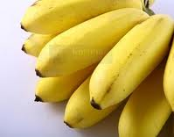 | Banana - Neinthram:
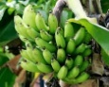 | Banana - Poovam
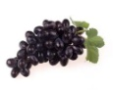 | Black Grapes
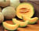 | Cantaloupe
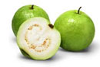 | Guava
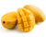 | Mango
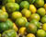 | Mosumbi
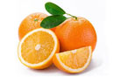 | Orange
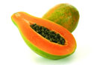 | Papaya
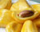 | Jack Fruit
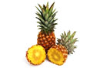 | Pineapple
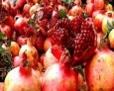 | Pomegranate - Kabul
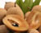 | Sapota
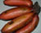 | Sev-vazhai
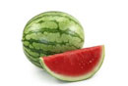 | Watermelon

Pic. Name |  | Pack.Qty. | Rate in USD
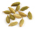 | Cardamom (Elakkai)
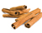 | Cinnamon (Pattai)
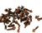 | Clove (Elavanga Poo)
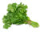 | Coriander (Kothamalli)
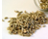 | Fennel (Sombu)
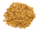 | Fenugreek (Venthayam)
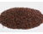 | Mustard (Kadugu)
 | Banana Leaf (Vazhai Elai)
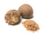 | Nutmeg (Zhathikkai)
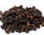 | Pepper
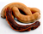 | Tamarind (Puli)
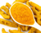 | Turmeric (Manjal)
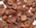 | Areca Nut (Pakku)
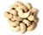 | Cashew Nut (Munthiri)

Pic. | Name | Pack.Qty. | Rate in USD
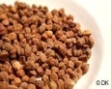 | Chenna Black
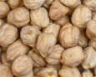 | Chenna White Big
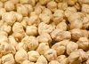 | Chenna White small
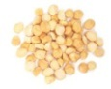 | Dhal - Gram
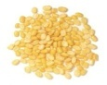 | Dhal - Moong
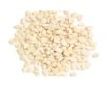 | Dhal - Orid
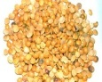 | Dhal - Toor
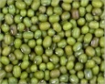 | Green Gram Dhal
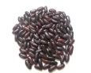 | Rajma - Black
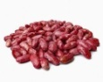 | Rajma - Pink
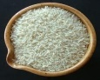 | Rice - Basmathi
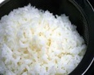 | Rice - Boiled
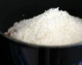 | Rice - Double Horse Sortex LG
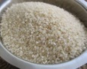 | Rice - Idly
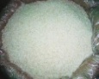 | Rice - India Gate Basmathi
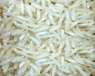 | Rice - Karnataka Ponni
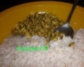 | Rice - Nirapara Silky
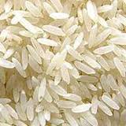 | Rice - Raw
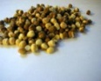 | Roasted Gram

Name | Pack.Qty. Rate in USD
Egg Rate

